Project Title
LeapCard_Application_Process_Automation
Madhava Lakshmi Satya Mohan Samanthakurthi

Introduction
The report elaborates on the design, development, and deployment of the RPA solution "LeapCard_Automation," which aims to automate the validation of student Leap Card applications. The project purposes to solve the inefficiencies and scope for human-induced errors in manually processing these applications.
Currently, the manual system can be described as repeating tasks, very slow processing, and inconsistent application of business rules. This automation wants to develop a strong and reliable process-facing high volumes of applications with speed and accuracy.
The project scope includes the following:
- Read applicant data from a structured file system
- Apply a series of business rules to each application for validation
- Make decisions to approve, put under manual review, or reject applications
- Generate consolidated output reports in CSV format
- Automatically inform applicants of their approval status via email
The solution is developed in UiPath Studio and is meant to execute on a local machine. All file operations use relative paths to maintain portability and provide offline use.
2. As-Is Process Analysis

The manual process for validating Leap Card applications is a linear and labour-intensive workflow.
Process Description:
- An administrative officer is to receive a batch of applications in digital folders. One by one, the officer must:
- Open the applicant's folder.
- Open the applicant_data file to read the core data.
- Manually calculate the applicant's age from the date of birth specified.
- Confirm that the calculated age is within the eligible range (17-25).
- Check whether the academic year is the current, valid one.
- Check if the payment has been authorized.
- Check the selfie versus the ID (passport), visually estimating a match-this is quite subjective.
- Approving, rejecting, or flagging the files for a second opinion (manual review) based on the checks.
- Open the corresponding master spreadsheet (such as approved_applications.xlsx).
- Copy applicants' details into the correct spreadsheet.
- Compose and send an email to the applicant informing them of the result manually.

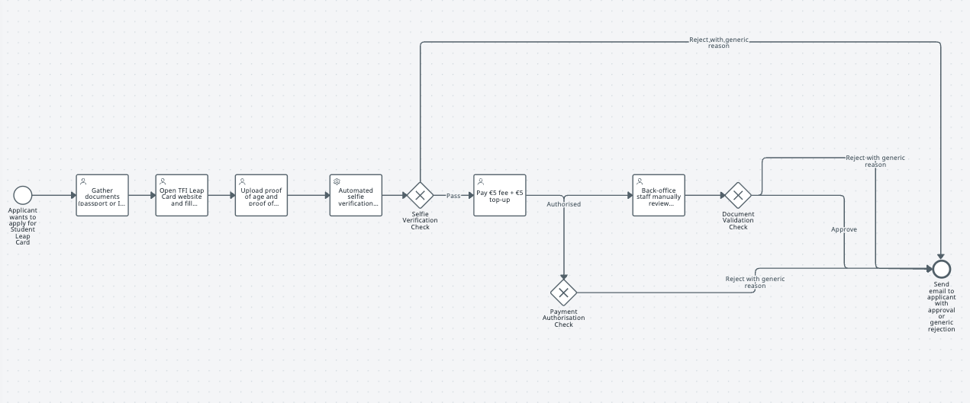
Fig: As-Is Process Flow

Manual Process-related Issues:
- Too Time-Consuming: During peak periods, countless manual operations have to be performed, but the slow procedures make it inefficient.
- Errors: Data entry and validation are manual and as such may result in human errors, such as erroneous rejections or approvals.
- Subjectivity: Selfie-to-ID matching is subjective and can yield an inconsistent result.
- Unavailability of Audit Trails: Tracking paper-based applications, along with the status of each, and an explanation of the outcome is difficult due to lack of some kind of automated registry system.

3. To-Be Process Design
The fully automated workflow streamlines the validation process from beginning to end.
Process Description:
The RPA bot begins the process. It first prepares the environment: a clean output directory is created for that particular run. The bot then loops through each applicant's subfolder within the main "SampleApplicants" directory. For each applicant, the bot performs the following set of operations:
- Reads data from "applicant_data.csv."
- Computes ages of applicants and checks if they fall within the required age range of 17-25.
- Check for the validity of the academic year, payment authorization status, and criteria for selfie match scores according to the listed business rules.
- Depending on validation results, the application is given a status of "Approved," "Manual Review," or "Rejected" with a reason listed.
- Writes the results (application ID, name, status, and reason) to the corresponding CSV file (approved.csv, manual_review.csv, or rejected.csv).
- Sends an email notification to the applicant containing the result and reason.

The procedure will repeat until all applicant folders have been processed.

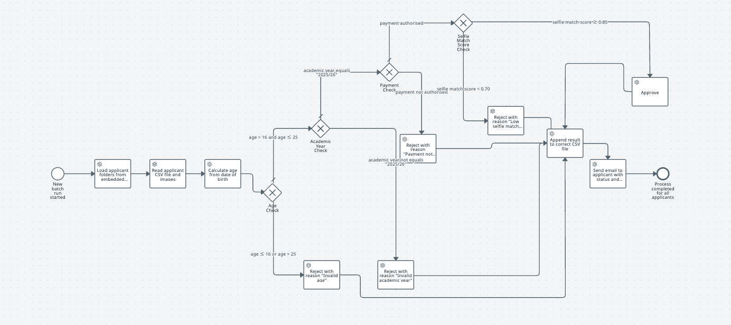
Fig: To-Be Process Flow

Benefits of Automation:

- Speed and Efficiency: The bot takes only a few minutes to analyze hundreds of applications; a crazy amount of time would be taken for a human to do this much work.
- Accuracy and Consistency: The business rules are applied in-fairness to all applications so that no bias or subjectivity is granted.
- Better Auditability: The output CSV files present the exact timestamped record of all the processed applications with their result, all in form of auditable document.
- 24/7 Operation: The bot can be scheduled to run any time, during and beyond office hours, so as to keep the processing going.

4. RPA Tool and Technology Selection

The primary tool that has been selected for automation in the project is UiPath Studio. The justification for this choice is that UiPath, being a market-leading RPA platform, offered a very easy, visual environment to build workflows, good debugging tools, and a vast out-of-the-box library of activities to handle files, data manipulation, and integration.
Technologies Used:
- UiPath Studio: To design and develop the core automation workflow.
- UiPath Activities:
  - File Activities:
Path Exists, Delete Folder, Create Directory, Enumerate Directories, Read CSV, Write CSV to handled the data and output files.
  - Data Manipulation:
Standard VB.NET functions within UiPath were used for date/time calculations (age) and conditional logic (If/Else If activities).
  - SMTP Mail:
Send SMTP Mail Message activity to send email notifications using a conventional Gmail account, evidencing integration with external services.
- Data Sourcing:
  - Kaggle: The synthetic passports dataset from Kaggle was used to create realistic applicant profiles. (https://www.kaggle.com/datasets/trainingdatapro/generated-passports-segmentation).
  - ChatGPT: Supplementary sample details were generated like from passport images the selfies, student id card images to populate the application run flow.

5. Implementation and Development

The "LeapCard_Automation" workflow is contained within a single UiPath sequence that is heavily commented for clarity. The development follows the specific requirements outlined for the project.

The "LeapCard_Automation" workflow is within a single UiPath sequence and, in that sense, heavily commented so as to offer clarity. Development here has been done as per the specific requirements given for this project.
Workflow Structure:
- Initialization:
- The OutputRootPath gets defined using Path.Combine(Environment.CurrentDirectory, "Output").
- If the directory exists, the workflow goes on to delete any CSV files lying there. If not, it sets up the directory.
- Three CSVs are created afresh: approved.csv, manual_review.csv, rejected.csv. The headers needed: application_id,full_name,status,reasons.
2.Data-Processing Loop
- The SampleRootPath gets defined using Path.Combine(Environment.CurrentDirectory, "SampleApplicants").
- Then the For Each activity loops through all subdirectories within SampleRootPath.

Business Rule Evaluation (Inside the Loop):

  - For each applicant folder, the applicant_data.csv is read into a DataTable.
  - Age Calculation: The date of birth is read, and the applicant's age is calculated as of the current date. An If condition checks if the age is between 17 and 25 (inclusive of 25). If not, the application is marked for rejection with the reason "Applicant age outside allowed range (17–25)".
  - Academic Year: An If condition checks if the academic_year column equals "2025/26". If not, the application is rejected with the reason "Invalid academic year".
  - Payment Authorization: An If condition checks if payment_authorised is True. If not, it's rejected with the reason "Payment not authorised".
  - Selfie Match Score: A nested series of If/Else If conditions evaluates the live_selfie_match_score:
    - If < 0.70, it is rejected with the reason "Low selfie match score (<0.70)".
    - If >= 0.70 and < 0.85, it is flagged for "Manual Review" with the reason "Selfie match score in manual review band (0.70–0.85)".
    - If >= 0.85 and all previous checks have passed, the status is set to "Approved".

Output and Notification:

  - A Switch activity is used based on the final status ("Approved", "Manual Review", "Rejected").
  - The corresponding case appends the applicant's data (application_id, full_name, status, reasons) to the correct output CSV file.
  - The Send SMTP Mail Message activity is then called. It is configured with input arguments for server details and credentials. The subject and body of the email are dynamically populated with the applicant's name, application ID, and the outcome of the validation.

6. Testing and Results

A structured testing plan was executed to ensure the reliability and accuracy of the automation.
Test Plan:
Test cases were designed to cover every business rule and decision branch:
- Approved: An applicant profile meeting all criteria (age 20, correct academic year, payment true, selfie score 0.90).
- Rejected (Age): An applicant aged 16 and another aged 26.
- Rejected (Academic Year): An applicant with academic year "2024/25".
- Rejected (Payment): An applicant with payment_authorised set to False.
- Rejected (Selfie): An applicant with a selfie score of 0.65.
- Manual Review: An applicant with a selfie score of 0.75.
- Multiple Rejection Reasons: An applicant who is too young and has an invalid academic year.

Summary of Results:
The bot performed flawlessly across all test cases. In each scenario, the applicant's data was written to the correct output CSV file with the appropriate status and reason.
- The "Approved" applicant appeared only in approved.csv.
- All "Rejected" applicants were correctly logged in rejected.csv with the first reason for failure encountered by the logic.
- The "Manual Review" applicant was correctly written to manual_review.csv.
- Email notifications were successfully generated and sent for each case with the correct dynamic content in the subject and body.
The output files served as a clean and accurate log of the bot's run, confirming that the data handling and business logic were implemented correctly.

- Cost-Benefit Analysis

This analysis provides a high-level estimate of the costs and benefits associated with deploying the "LeapCard_PoC" solution.
Assumptions:
- Manual Processing Time: 5 minutes per application.
- Application Volume: 10,000 applications per year (concentrated in late summer/early autumn).
- Administrative Salary: Average salary for an Administrative Assistant in Dublin is approximately €32,000 per year, or €16.41 per hour (based on a 37.5-hour week).

Costs:
- Development Cost:
  - Estimated development and testing time: 20 hours.
  - Assuming a freelance developer rate of €50/hour, the one-time development cost is €1,000.
- Software Cost:
  - UiPath Community Edition was used, so software licensing cost is €0 for this PoC.
- Operational Cost:
  - The bot runs on existing infrastructure, so operational costs are negligible.
Benefits (Annual Savings):
- Time Saved:
  - Total manual processing time: 10,000 applications * 5 minutes/application = 50,000 minutes = 833.3 hours.
- Cost Savings:
  - Annual cost of manual processing: 833.3 hours * €16.41/hour = €13,674.
- Return on Investment (ROI):
  - ROI = (Annual Savings - Annual Cost) / Total Investment
  - ROI = (€13,674 - €0) / €1,000 = 1367% in the first year.
In addition to direct cost savings, the automation provides significant intangible benefits, including higher accuracy, better compliance with business rules, and improved applicant satisfaction due to faster processing times.

- Conclusion

The "LeapCard_Application_Process+Automation” project successfully demonstrates the power of Robotic Process Automation in transforming administrative workflows. The developed solution effectively automates the end-to-end process of Leap Card application validation, adhering to all specified business rules and requirements. The bot is efficient, accurate, and provides a full audit trail through its structured output files and email notifications.
Future Improvements:
- OCR Integration: Enhance the bot to use Optical Character Recognition (OCR) to extract data directly from scanned documents like passports and student ID cards, removing the dependency on a pre-populated CSV file.
- AI-Powered Facial Recognition: Integrate a dedicated AI service, such as the Microsoft Azure Face API, to perform a more accurate and reliable comparison between the selfie and the ID photo, replacing the sample match score.
- Exception Handling and Unattended Deployment: Implement a more robust exception handling framework and deploy the bot in an unattended mode on a server, allowing it to run on a schedule without human intervention.
This project serves as a strong foundation for a production-grade automation solution that can deliver significant value to any organization managing similar application processes.
- References

- Kaggle. (2020). Generated Passports Segmentation. Available at: https://www.kaggle.com/datasets/trainingdatapro/generated-passports-segmentation (Accessed: 8 August 2025).
- Leap Card. (2024). Young Adult and Student Card Information. Available at: https://about.leapcard.ie/young-adult-and-student-card-launch (Accessed: 8 August 2025).
- Lucidchart. (n.d.). BPMN Tutorial. Available at: https://www.lucidchart.com/pages/tutorial/bpmn (Accessed: 8 August 2025).
- UiPath. (n.d.). Send Mail Activities. Available at: https://docs.uipath.com/activities/other/latest/productivity/send-mail (Accessed: 8 August 2025).
- UiPath Marketplace. (n.d.). Microsoft Facial Recognition. Available at: https://marketplace.uipath.com/listings/microsoft-facial-recognition (Accessed: 8 August 2025).

